**Chapter 1 Assignments**

**Chapter Review:**

1. B
2. D
3. D
4. A
5. C
6. A
7. B
8. D
9. D
10. A
11. B
12. C
13. D
14. C
15. B
16. A
17. B
18. A
19. B
20. 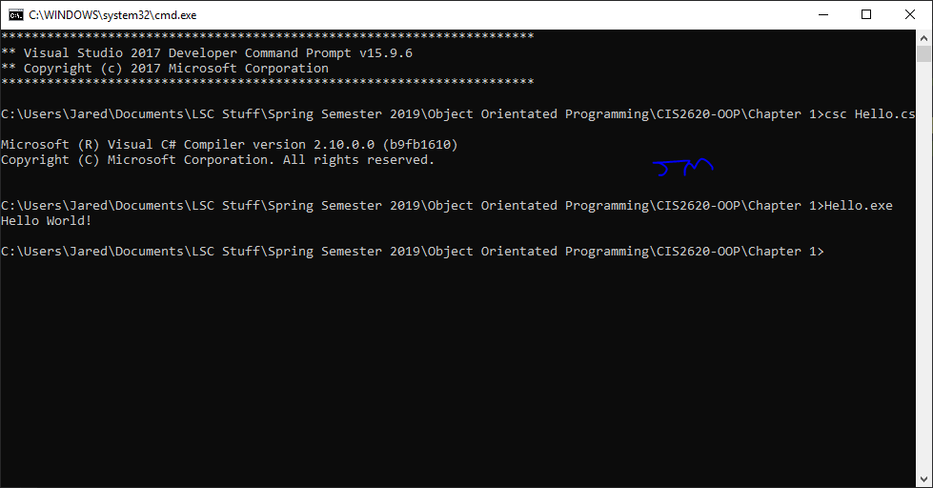 B

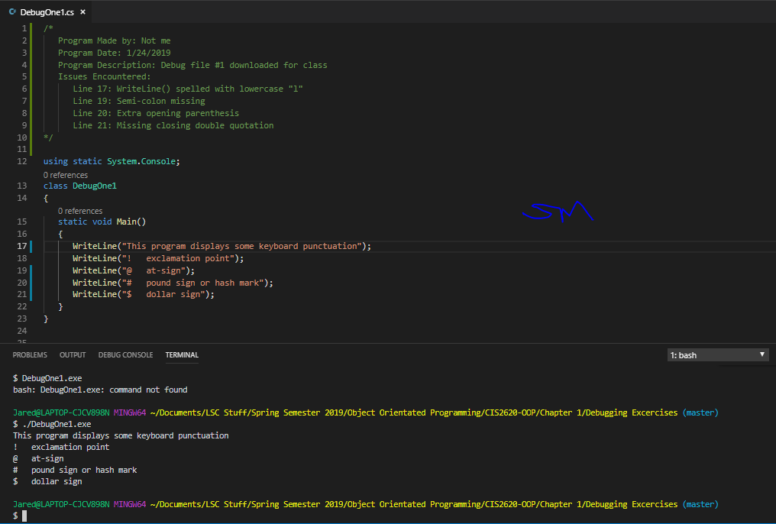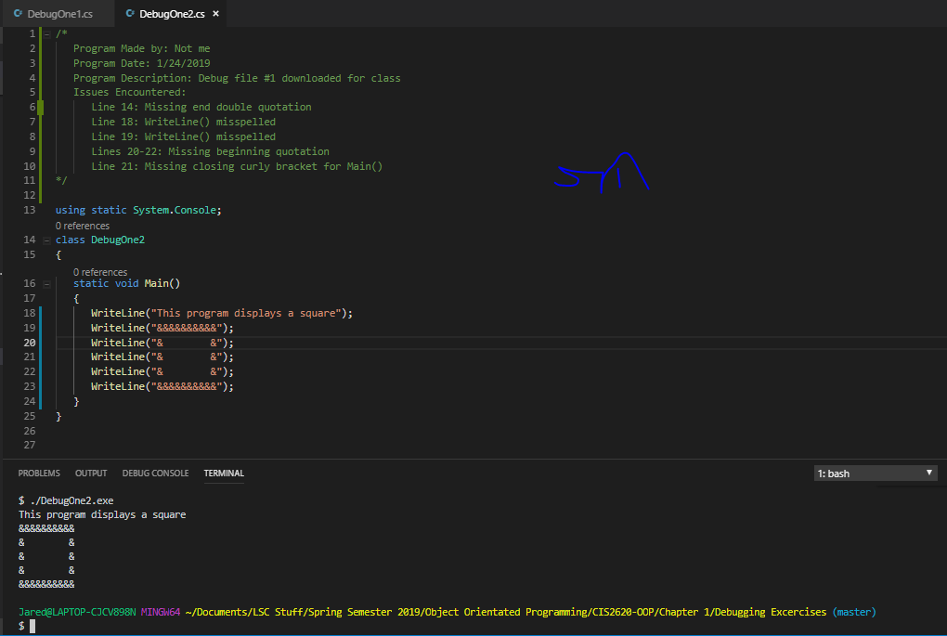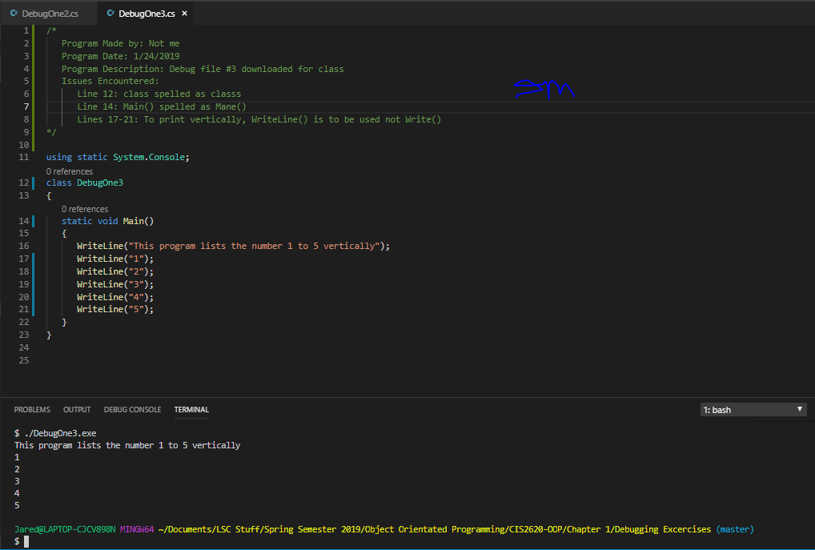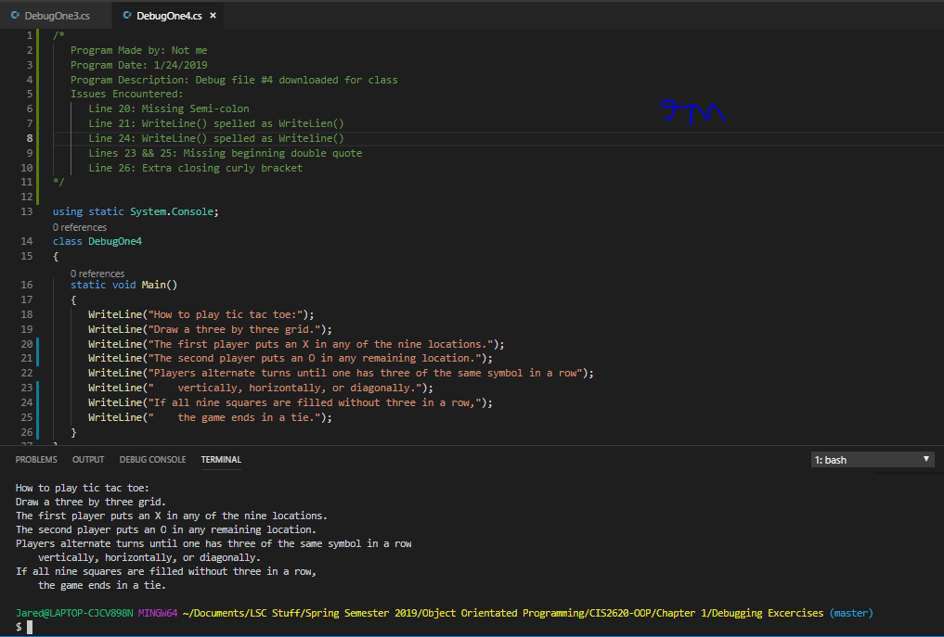

**1-9d Exercises**

1. Identifiers
   1. Legal, not conventional
   2. Legal, conventional
   3. Illegal
   4. Illegal
   5. Illegal
   6. Illegal
   7. Legal, not conventional
   8. Legal, Conventional
   9. Legal, not conventional
   10. Legal, not conventional
   11. Legal, not conventional
   12. Illegal
2. Attributes
   1. Channel, Show Length, Rating
   2. Address, Length, Type
   3. Employer, Company, Location
   4. Balance, PIN, password
3. Classes
   1. Family, People
   2. Store, Retailers
   3. Country, Historical Places
   4. President, Historical Figures